MODEL SG 905 MANIFOLD INSTALLATION INSTRUCTIONS

General Precautions –

- Installation should be performed by personnel knowledgeable in the handling of compressed gases.
- Choose a location well ventilated for installation
- Use proper precautions when dealing with any compressed gas.
- The user should be familiar with the chemical and reactive properties of the gas being used (Read the MSDS of the gas being used).

Reference Material –

The following safety bulletins are available on the Compressed Gas Association’s website (www.cganet.com) or at (703) 412-0900:
- SB-2 Oxygen Deficient Atmospheres
- SB-10 Correct Labeling & Proper Fittings On Cylinders/Containers
- SB-15 Avoiding Hazards In Confined Work Spaces During Maintenance,
Construction And Similar Activities
- SB-19 Potential Valve Thread & Cylinder Thread Mismatch

Installation Instructions –

Checking contents –

- Remove contents of manifold system from packaging.
- Inspect components visually to insure there is no damage. Caution: Do not install damaged components.
- Your gas distribution system will include of one or more of the following components:
(See Fig. 1 below)

- Center section (switchover module with regulators and/or control valves)
- Left header with wall mounting brackets (if using more than one cylinder per side)
- Right header with wall mounting brackets (if using more than one cylinder per side)
- Flexible pigtails

4) Your gas distribution system does not include the following:
- mounting screws for the center section
- mounting screws for the left/right header wall brackets (if used)

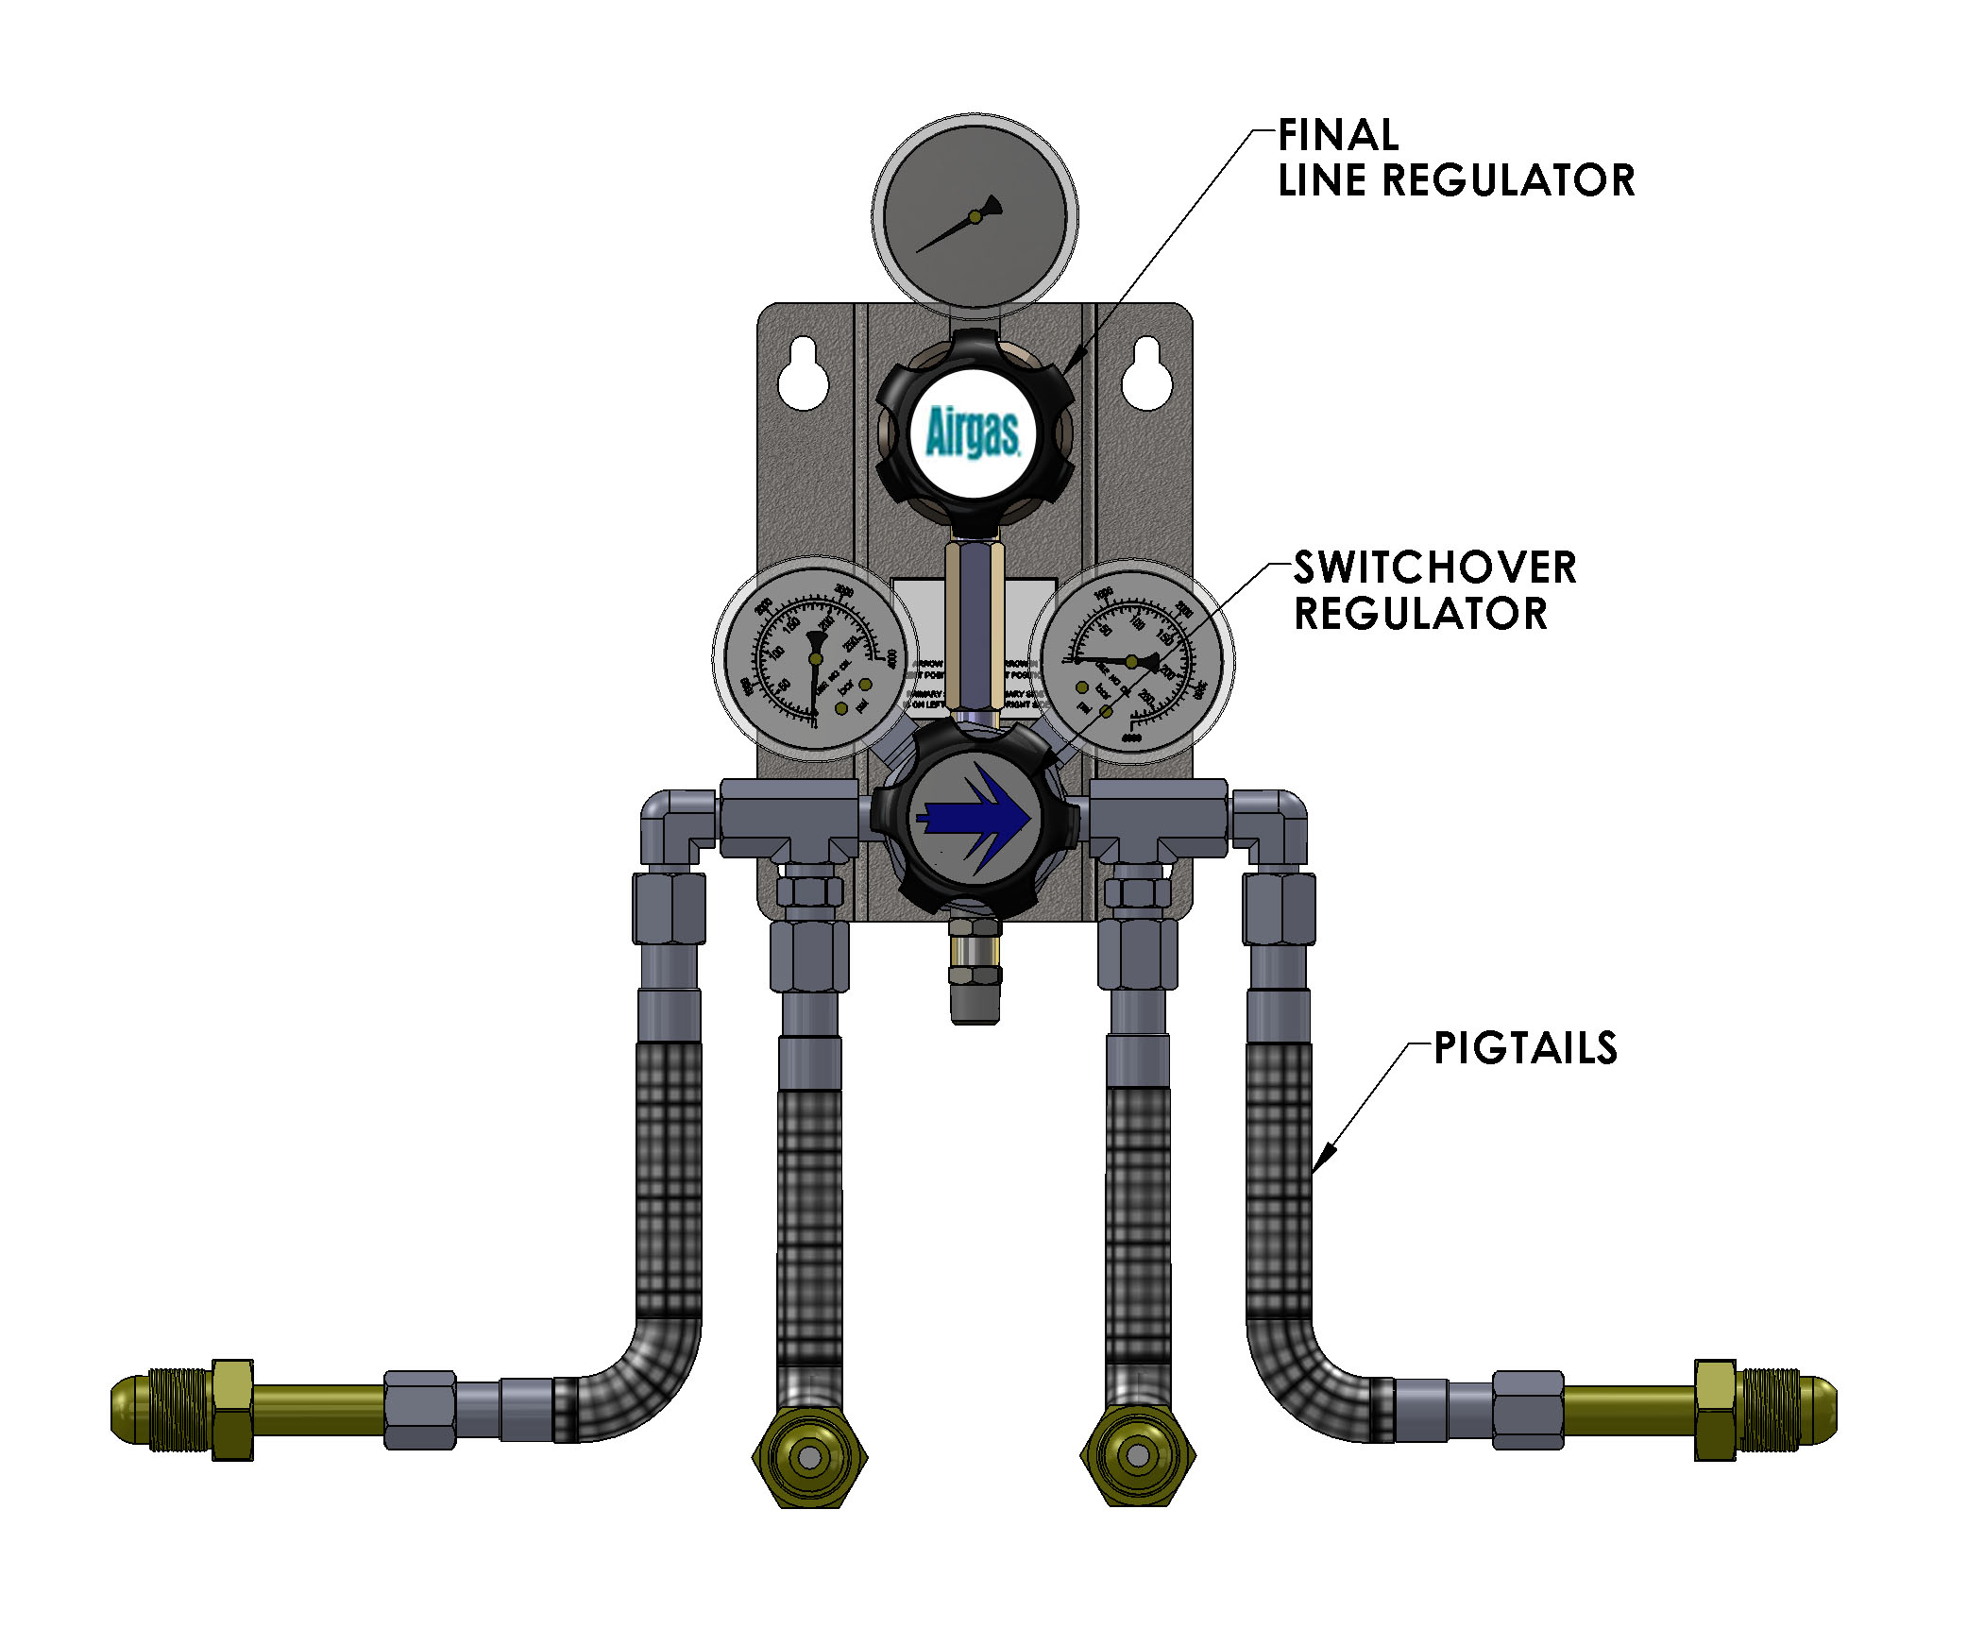
Figure 1

Mounting the Center Section –

In a well ventilated area, mount the center section to a wall, bracket or stand using mounting screws or bolts (not included) at each corner. The use of wall anchors may be necessary due to the weight of the center section.

Note: Insure the mounting height of the center section is correct for the cylinder size and height being used. Additionally, if headers are used, make sure the installation area is adequate to accommodate the length of the headers and the number of cylinders used.

Mounting the headers – (See Fig. 2 below)

If more than one cylinder on each side is used, mounting the header bars to a wall or other permanent structure will be necessary.

Mount the headers to the wall using the “L” shaped brackets (supplied) and mounting screws or bolts (not supplied). Tighten the headers to the mounting brackets with the u-bolt (supplied).

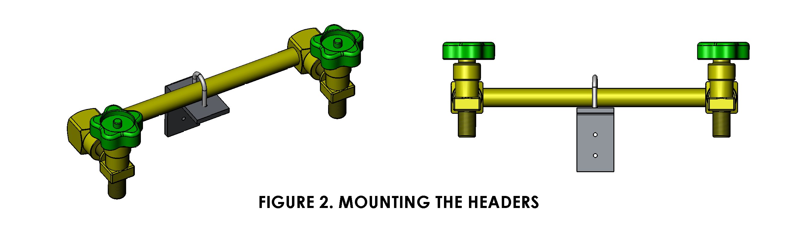

Installation of Flexible Pigtails –

One end of the pigtail will connect directly onto the center section and should be wrench tight using Teflon tape as a thread sealant. The other end will have

- a CGA connection with a check valve or flashback arrestor specific for the gas being used which will attach to the cylinder, or

- a swivel connection which would attach to the header bar. This end requires no thread sealant
and should be wrench tight.

Completing the installation –

The Model SG 905 pressure differential switchover system is designed to automatically switch from the primary bank (right side) to the reserve bank (left side) when cylinder pressure goes below 200 psig. Follow the steps below to insure that the system is set up properly after installation and assembly of all the parts.

- After installation of the manifold system, ensure all connections are wrench tight. Back off the adjusting knob (counter-clockwise) of the top line pressure regulator all the way.
- For all Model SG 905 systems, the right side will be the primary input and the left side will be the reserve.
- Before pressurizing the system, insure that the knob on the primary regulator is turned all the way to the right and that the arrow is pointing in the right direction.
- Pressurize the primary side and check for leaks.
- Pressurize the reserve side and check for leaks.

***Do not use the system if any leaks are detected. Tighten fittings to correct or contact Harris Products Group for additional information.

- If no leaks are detected, the system should now be ready for use.
- Adjust the top line pressure regulator to the appropriate setting by turning the knob clockwise.

Additional Instructions

- After the primary side is depleted the system will automatically switch over to the reserve side. The reserve side will then be used while the user changes out the empty cylinders on the primary side.

- Before changing out empty cylinders on the primary side, turn the handle on the primary regulator to point to the reserve side. The gas from the reserve side will be in use as long as this handle points to the reserve side. When cylinder change-out for the primary side is complete, the handle can be turned back to the primary side or left on the reserve side to deplete these cylinders.

